

**Project Report On**

**SEA SHIPS**

**Table Of Contents**

1. **Acknowledgments**
2. **Information About Developers**
3. **Introduction About Project**
4. **Analysis**
5. **Screen Shots**
6. **Final Statement**

**Acknowledgments**

The combine Study on this project is an honor for our group members.

We were eager to make such a dynamic and interesting project, which may provide us with a huge amount of practical knowledge and will help us use our skills efficiently.

Our heartiest appreciation and gratitude towards our teachers, whose help, dedication and encouragement has helped our team members to successfully, achieve our goals.

We are grateful to Aptech for providing us necessary facilities and the support which we needed and also for providing us the opportunity to practically implement what we have learned, which will help, help us in future.

**Information About Developers**

|  |  |
| --- | --- |
| Student1424565 | Areesha Khaliq |
| Student1425773 | Bushra Arshad |
| Student1424829 | Asad Raza |
| Student1430589 | Muhammad Fahad |

**Introduction About Project**

Sea shipping stands as a cornerstone of global trade, serving as the primary artery through which goods traverse the vast expanses of the world's oceans. From container ships laden with a myriad of products to colossal vessels transporting raw materials, sea shipping is the lifeblood of interconnected economies.

This project seamlessly combines HTML, CSS, JavaScript, jQuery, and Bootstrap to create an immersive and user-friendly website that caters to both aesthetic appeal and functionality.

By leveraging modern web technologies, the website provides a visually stunning experience while ensuring seamless navigation and easy access to information.

Whether it's exploring the extensive product catalog, requesting a quote, or contacting the company, Sea shipping a vital force in global trade, connects nations by navigating the worlds oceans, transporting good and fostering economic interdependence.

A sea ship, often simply referred to as a ship, is a large watercraft designed for transportation on the open seas, rivers, or other navigable waters. These vessels have played a crucial role throughout human history, serving various purposes such as trade, exploration, military operations, and passenger transportation.

**Analysis**

**Purpose**

The purpose of sea shipping is multifaceted, encompassing the facilitation of global trade, cost-effective transportation, access to diverse markets, infrastructure development, environmental considerations, and the transport of bulk and heavy cargo. It plays a vital role in shaping the economic, social, and geopolitical landscapes on a global scale.

Sea shipping provides businesses with access to diverse markets worldwide. It enables companies to reach customers in different regions, fostering economic growth and expanding market opportunities beyond local borders.

**Working**

Working on a sea ship is a unique and demanding experience that requires a combination of maritime expertise, adaptability, and resilience. Seafarers, comprising a diverse crew of officers, engineers, and deckhands, navigate the challenges of the open ocean to ensure the smooth operation of the vessel. Their responsibilities range from navigation and maintenance to managing cargo and adhering to strict safety protocols.

**Snapshots**

**Home page**

This is the home page of website

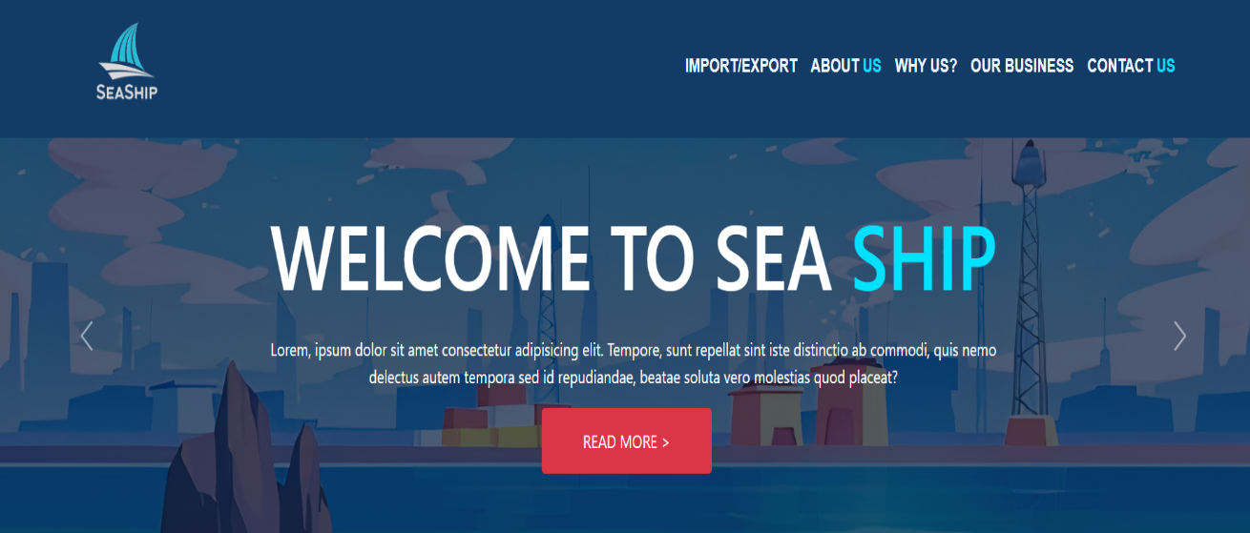

"The sea whispers tales of exploration, daring souls who dared to dream beyond the horizon."

**ABOUT US**

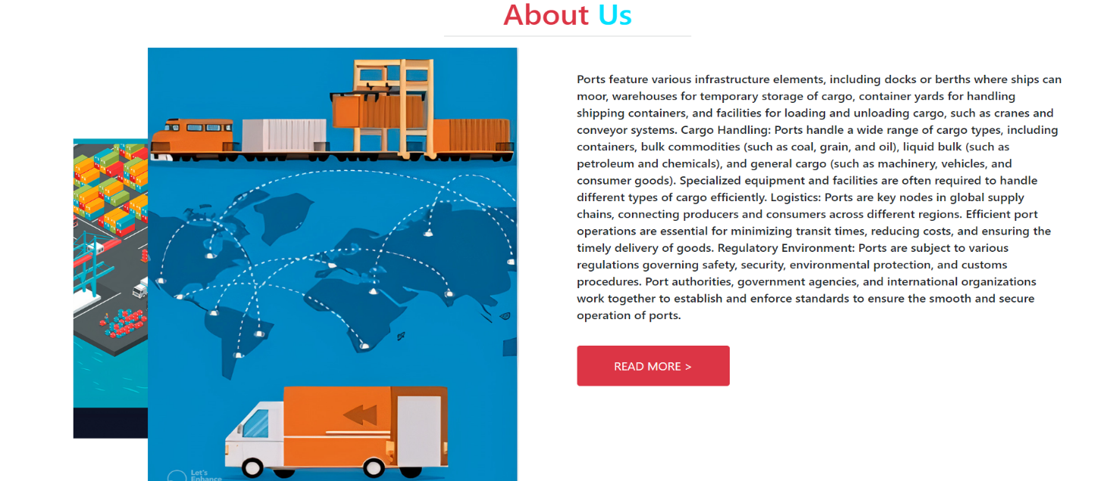

**Product page**

From this page customer can shop and explore furniture

  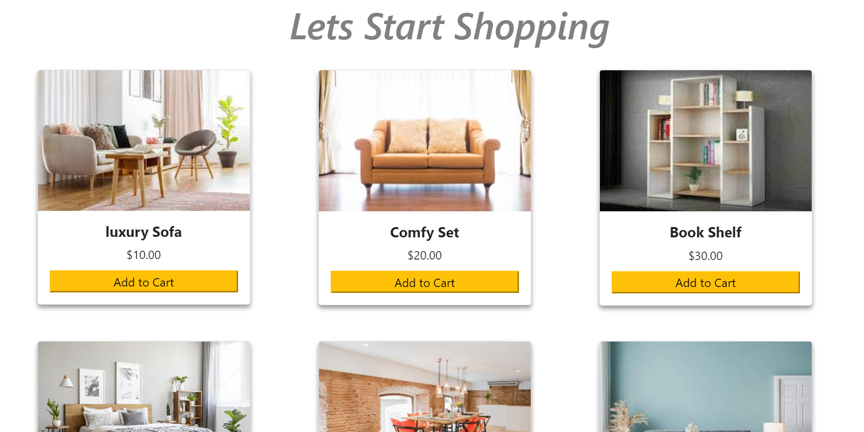

**Contact us page**

Customers can contact us through this page

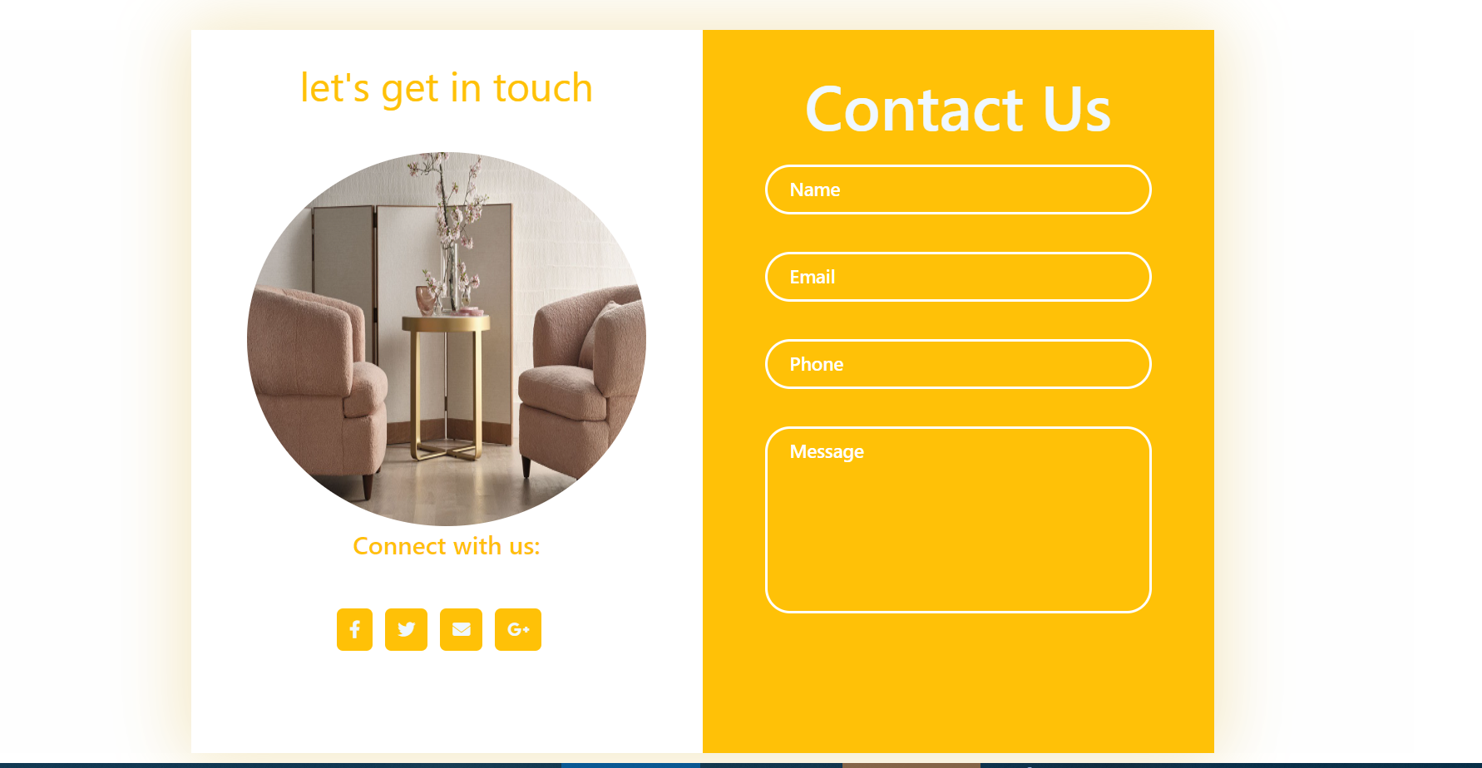

Through this map customers can visit our store

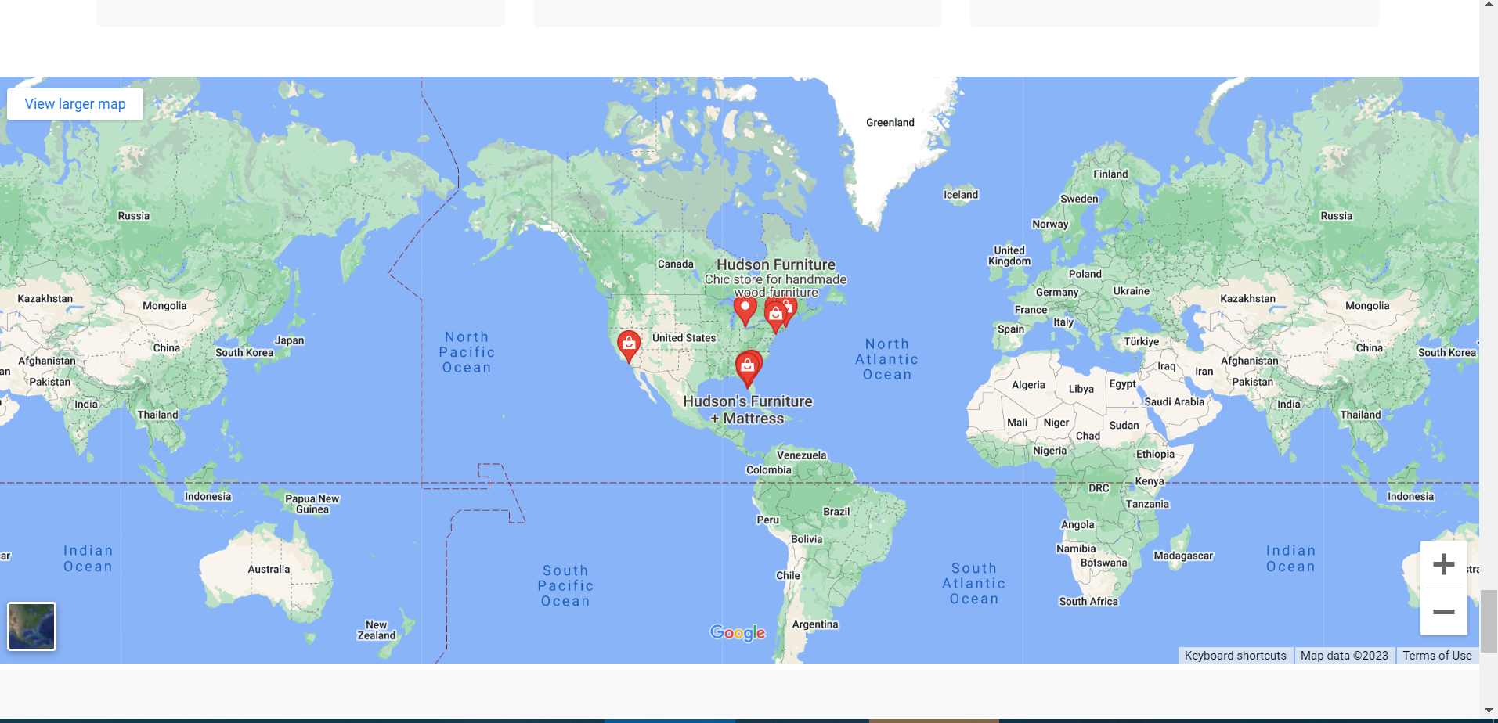

**About us page**

From this page customer can know our goals and history and team

  

**Signup page**

From this page customer can sign up stayed connected with us

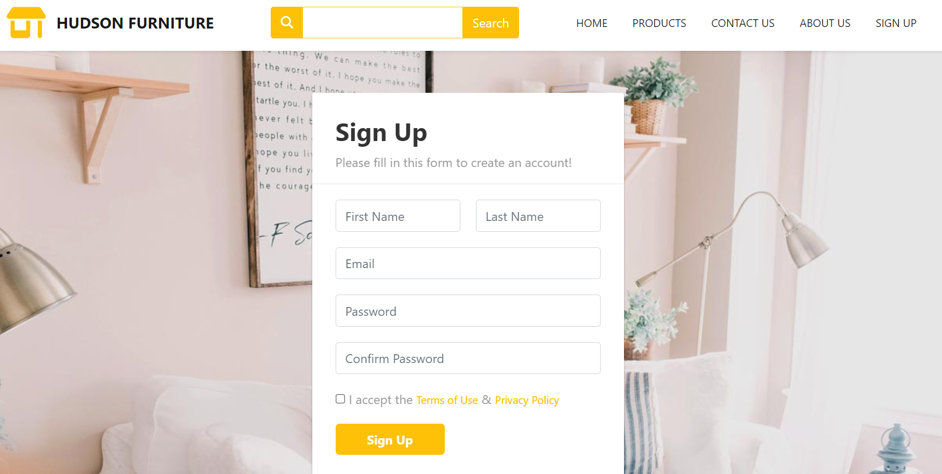

**Track order page**

From this page customer can track their order

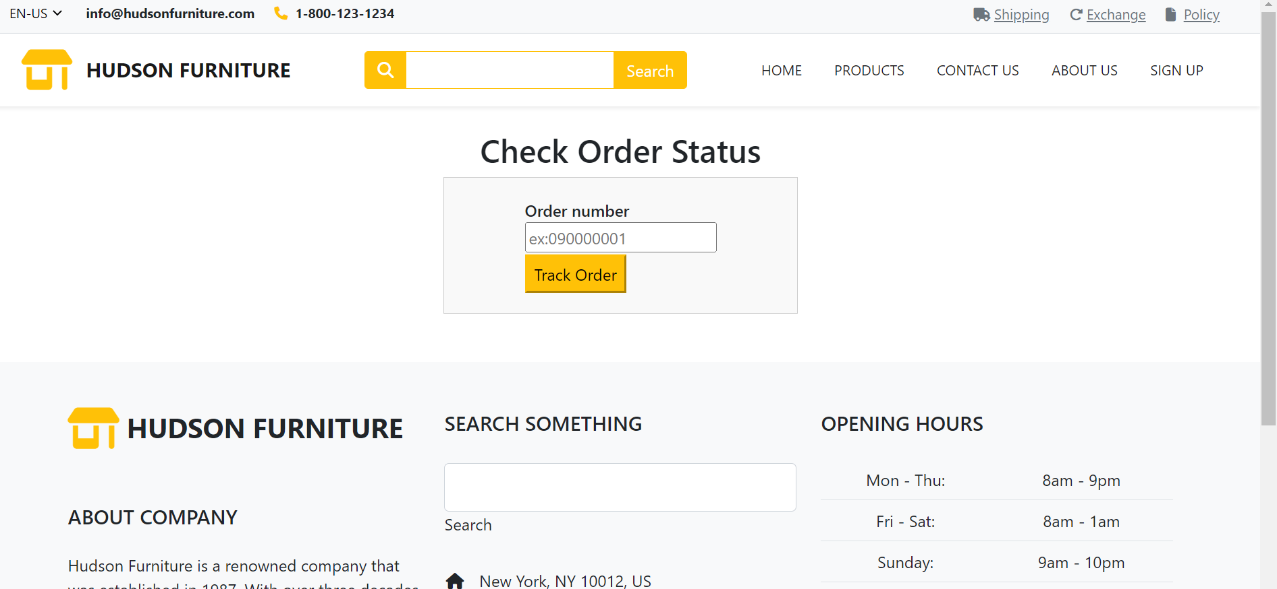

**Exchange product page**

From this page customer can exchange their product

**Policy page**

From this page customer can know about our policies

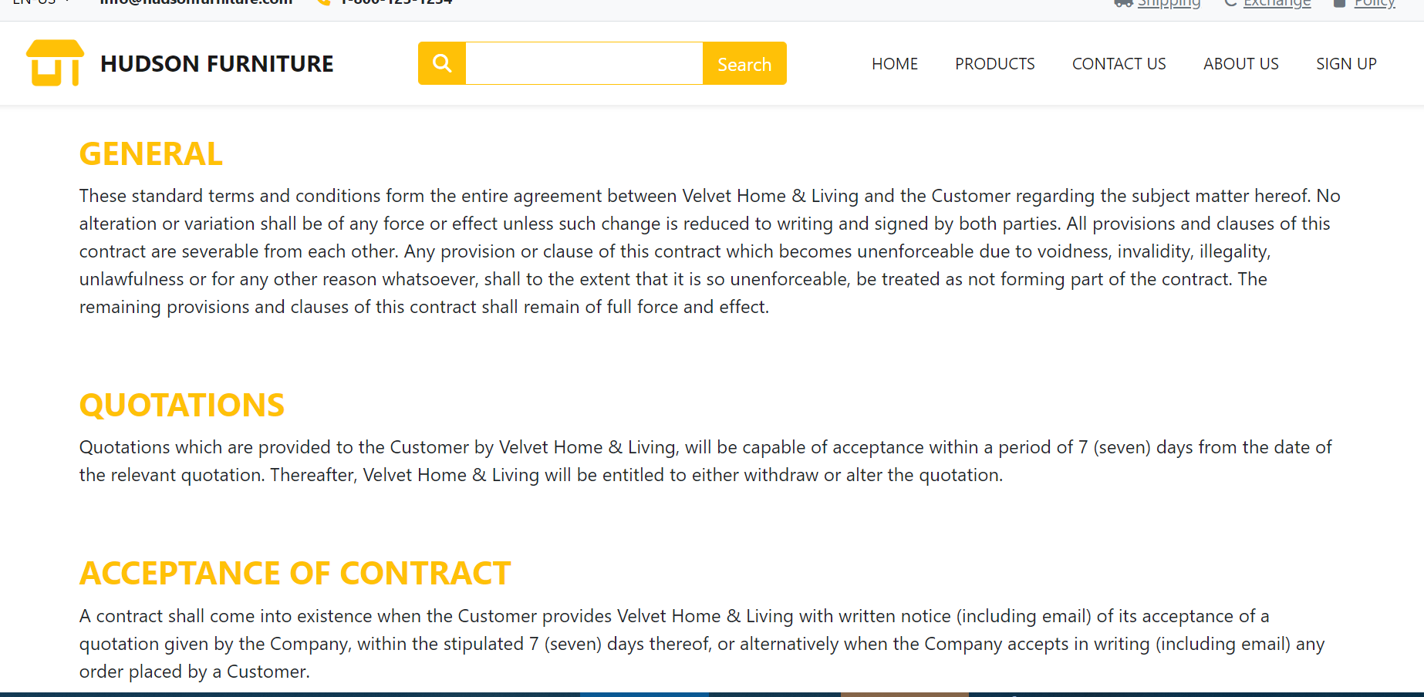

**Final Statement**

This E Project was created with Firm Determination. We students did lot of hard work to complete this project on time.

We did our best to made this project perfect, work full, help full, easy to use and Qualified as much as possible.

We Kept the future technologies and usage in our mind while making this project.

We hope That APTECH will like our project and will appreciate our hard work and Firm Determination.

THANK YOU!

**Documentation Created By**

**AREESHA KHALIQ**